**Test Case 12**

**System:** Bench

**Description:** Black box testing to check the turning off of notifications.

**Severity:** 3

**Instructions**

**Test 1**

1. Start the Bench application.
2. Click the button “Login” on the navigation bar.
3. Enter the email “team23project@gmail.com” into the text field labeled “Email address”.
4. Enter the password “12345678” into the field labeled “Password”.
5. Click the button “Login” below the field.
6. After the screen has loaded, click on the button “My Profile” on the navigation bar.
7. Click on the dropdown menu on the notification panel.

**Expected Result:** There should be two options on the dropdown menu. The button “Enable” allows the user to turn on notifications, and the button “Disable” allows the user to turn off notifications.

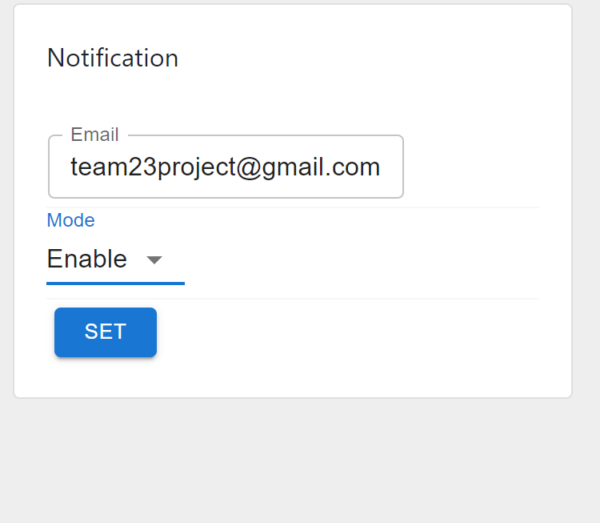

**Test 2**

1. Start the Bench application.
2. Click the button “Login” on the navigation bar.
3. Enter the email “team23project@gmail.com” into the text field labeled “Email address”.
4. Enter the password “12345678” into the field labeled “Password”.
5. Click the button “Login” below the field.
6. After the screen has loaded, click on the button “My Profile” on the navigation bar.
7. Click the button “Disable” in the dropdown menu.
8. Click the button “Set”.
9. On a different device, login as a different user and send TEAM 23 messages.
10. Check the gmail inbox of TEAM 23.

**Expected Result:** TEAM 23 should not receive any incoming email notifications regarding the incoming messages any more.

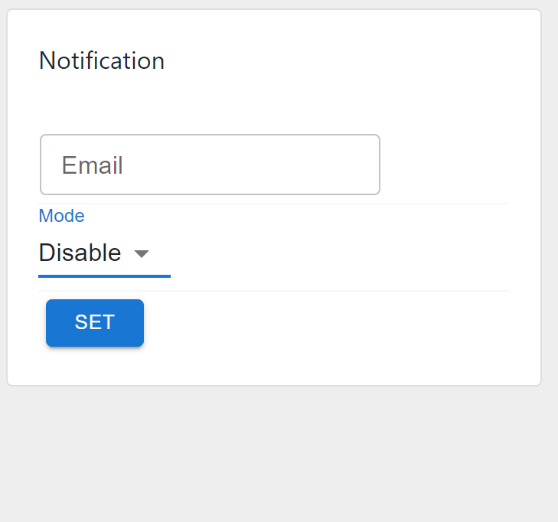

**Test 3**

1. Start the Bench application.
2. Click the button “Login” on the navigation bar.
3. Enter the email “team23project@gmail.com” into the text field labeled “Email address”.
4. Enter the password “12345678” into the field labeled “Password”.
5. Click the button “Login” below the field.
6. After the screen has loaded, click on the button “My Profile” on the navigation bar.
7. Click the button “Enable” in the dropdown menu.
8. Click the button “Set”.
9. On a different device, login as a different user and send TEAM 23 messages.
10. Check the gmail inbox of TEAM 23.

**Expected Result:** TEAM 23 should start to receive new incoming email notifications regarding the incoming messages again.

